**My Safety Plan**

**Sometimes life can get pretty difficult – to the point where you may not care about things that used to matter.** Remember, you are not alone. There are resources and people who want to help. Using these action steps can help keep you safe and more in charge of your emotional wellbeing. One step at a time, starting now.

*\*Asterisk denotes drop-down list*

|  |  |  |
| --- | --- | --- |
| **Student Information** | | |
| **Student:** | **Student ID:** | **Date:** |
| **School:** **\*** | **Grade:** **\*** | |

|  |
| --- |
| **Step 1 – Recognizing Warning Signs** |
| ***Isolating, drug use, feeling hopeless, angry, exhausted…*** |
|  |
|  |
|  |
|  |

|  |
| --- |
| **Step 2 - Using Internal Coping Strategies** |
| ***Things I can do on my own like deep breathing, music…*** |
|  |
|  |
|  |
|  |
|  |

|  |
| --- |
| **Step 3 - Using External Coping Strategies** |
| ***People and social settings that help distract me*** |
|  |
|  |
|  |
|  |
|  |

|  |
| --- |
| **Step 4 - Contacting Family/Friends Who Can Help** |
| ***People I can be honest with about what’s bothering me*** |
|  |
|  |
|  |
|  |
|  |

|  |
| --- |
| **Step 5 – Environmental Safety** |
| ***Making the environment safe (Plan for lethal means safety)*** |
|  |
|  |
|  |

|  |  |  |  |  |
| --- | --- | --- | --- | --- |
| **Step 6 - Turning to Professionals and Resources** | | | | |
| *Trusted adults can help. Who could you add to this list?* | | | | |
| **Resources for Teens** | **Browse, Call, Text, or Chat** |  | **Trusted Adult Name:** | **Phone:** |
| 24-hr Suicide Lifeline | Dial ‘988’ or call 1-800-273-8255 |  |  |
| 24-hr Crisis Text Line | Text ‘HEAL’ to 741741 |  |  |
| 24-hr Crisis Connections | 1-866-427-4747 |  |  |
| Safe Place – Find Shelter | Text ‘Safe’ to 4HELP |  |  |
| Sexual Assault Hotline | 1-800-656-HOPE |  |  |
| Teen Line | Text ‘TEEN’ to 839863 |  |  |
| Teen Link - Call 6-10pm | 1-866-833-6546 |  |  |
| Trevor Project – LGBTQ | Text ‘START’ to 678678 |  |  |
| Trans Lifeline | 1-877-565-8860 |  |  |
| 211 – Other Resources | Dial ‘211’ or go [Online](https://www.211.org/) |  |  |



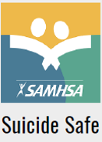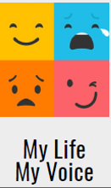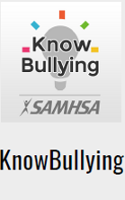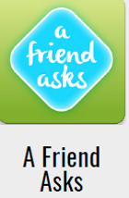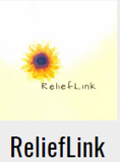

|  |  |
| --- | --- |
| **Step 7 - Keeping My Personal Space Safe** | |
|  | I let trusted adults help monitor my personal space |
|  | I let trusted adults know about any harmful items |
|  | I am keeping my personal environment safe |

*Form adapted from Stanley and Brown (2008)*